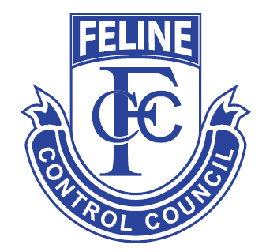
Feline Control Council (Victoria) Inc.
P.O. Box 110, Bayswater, Vic. 3153. Phone: (03) 9720 8811
Registered No.: AOO23723Y ABN 87 706 132 139
An Applicable Organisation under Domestic Animals Act
Application for Membership
NOTE: Please complete the following in Block Letters.
Mr/Mrs/Miss
Address
 |  |  |  | Postcode
Breed |  |  |  |  | Phone No:
E-mail Address

Members who renew membership on or after 1ST January are required to complete this
Application for Membership.
Late fee $25.00 applies
The financial year ends on 30th June. New applications made between 1st May and 30th June are accepted as membership for the period ending 30th June of following year.

The above details may be passed on to Club Secretaries and be included in listing of Members and Breeders for general enquiries. Your email address will be added to our mailing list so that we can keep you updated with any changes or information.

MEMBERSHIP FEES
Membership- Individual, Dual, Joint & Pensioner Full Year $60.00
Associate Membership Full Year $45.00
New Membership: 1st January to 30th June Half Year $30.00
New Associate Membership: 1st Jan - 30th June Half Year $22.50
Junior Membership: (10 To 16 years of age) Full Year $45.00
Date of Birth: …………………………………………….
Is your interest in BREEDING / SHOWING / PET ONLY Circle as applicable.
Are you a Council Domestic Animal Business (DAB)? YES / NO Circle as applicable
DAB Number: ……………………………………………
If yes, are you BREEDING / REARING / TRAINING / BOARDING / PET SHOP
New member joining fee. $25.00
Membership Renewal Late Fee after 1ST January $25.00
Cheque or MO enclosed for:

Internet Banking Details

BSB 013-260
A/c 440042036
Feline Control Council

Attach copy of receipt

Are you transferring from or have previously been a member of another controlling body? YES / NO
If YES, please state name of controlling body………………………………………………………….
Please include a copy of resignation letter to previous controlling body.

I/We hereby apply to be admitted as a member of the Feline Control Council (Victoria) Inc. (FCCV Inc) and if accepted
I/we agree to be bound by the Rules, Bylaws, Code of Practice (Ethics) and decisions made by the FCCV Management Committee.
I/We agree to abide by the Applicable Organisation Conditions of Application – member requirements.

Further, I/we hereby give an unconditional undertaking not to hold membership with any other Feline Registering Body in Victoria or participate in any show or exhibition not sanctioned by the FCCV Inc.

By submitting this signed application form, I am confirming I have read and will comply to the FCCV Code of Practice (FCCV website download) and Victorian Government Legislation, Domestic Animals Act 1994 and Amendments April 2013.

PRINTED NAME |  | SIGNATURE |  | DATE

Partnerships MUST have TWO Signatures

PRINTED NAME |  | SIGNATURE |  | DATE
The Rules, Bylaws & Code of Practice are published on the FCCV website and are available for inspection at the FCCV office.

